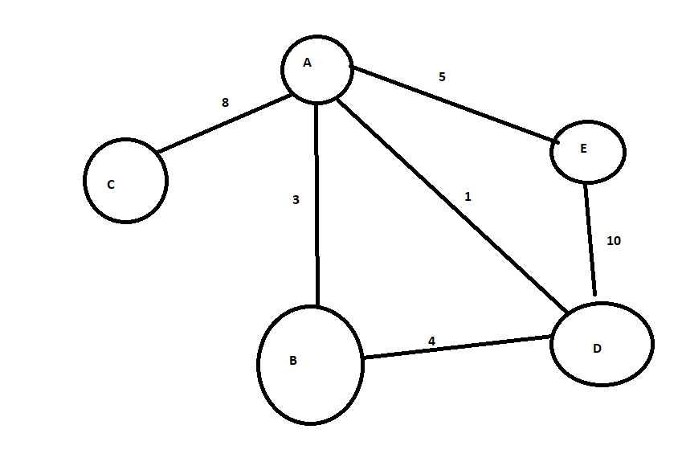

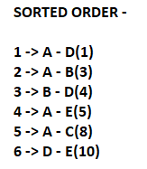

**1ST ITERATION –**

MST – 1

EDGES – 2 3 4 5 6

**2ND ITERATION –**

MST – 1 2

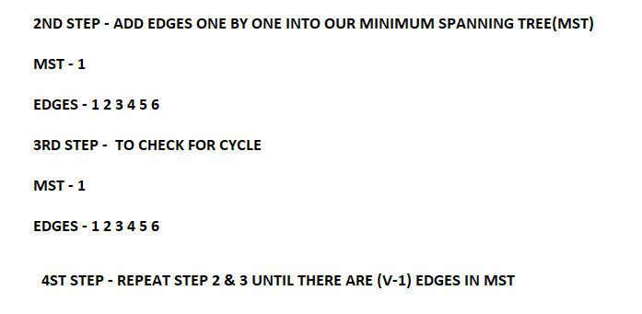EDGES – 3 4 5 6

**3RD ITERATION –**

MST – 1 2

EDGES – 4 5 6

**4TH ITERATION –**

MST – 1 2 4

EDGES – 5 6

**5TH ITERATION –**

MST – 1 2 4 5

EDGES – 6

**6TH ITERATION –**

MST – 1 2 4 5

EDGES –

VERTEX – 5

EDGES IN ORIGINAL GRAPH – 6

EDGES IN MST – 4 (5 -1)